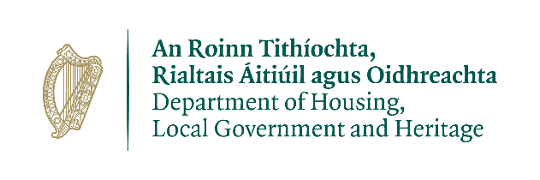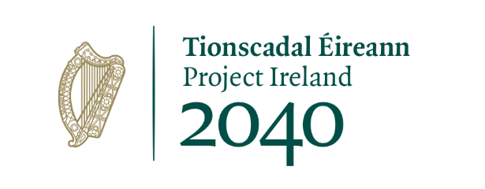

**Monday 08 March 2021**

**Urban Regeneration and Development Fund ‘Call 2’**

* **€25.8 million Midlands Projects**

**Laois County Council project**

**Portlaoise: A placemaking project for a Low Carbon Town Centre** - **€9 million**

Portlaoise is Ireland's first designated ‘Low Carbon Town’. This project will complement and build on the implementation of other ‘Low Carbon Town’ developments under the existing ‘Call 1’ project.

The ‘Call 1’ project is delivering cycle routes, E-Car charging points and low energy public lighting. This new project will also augment work underway on the Cultural Quarter project (funded under ‘Call 1’ of the URDF).

The ‘Call 2’ project includes:

* The completion of the Cultural Quarter.
* Public Realm Works - Market Square and Main Street.
* Pedestrianisation on Lower Main Street and upgrade of the Public Realm along Main Street from Market Square.
* Enhancing the streetscape on James Fintan Lalor Avenue to prioritise pedestrian access, cycling and public transport.
* Creation of urban development sites along James Fintan Lalor Avenue that are consistent with the principles of compact urban growth.

The **€9 million** in approved funding is in addition to **€9.06 million** in approved URDF funding for two projects ‘Portlaoise – A Cultural Quarter’ and ‘Portlaoise – A Low Carbon Town’ (‘Call 1’ projects).

Total URDF funding approved to date: **€18.06 million**

**Longford County Council project**

**Camlin Quarter Regeneration** - **€10.44 million**

This project involves the development of connections between critical functions of the town core to promote sustainable mobility, social equity and environmental integrity. This project aims to address long standing legacy issues in order to create an attractive environment for living, commerce and investment.

Utilising the Camlin River as a spine, the project will increase access to the positive social, economic and environmental influence and reach of the Albert Reynolds Peace Park and its facilities.

The project’s main focus points are:

* Barracks/Church Street with focus on placemaking and climate action initiatives.
* Little Water Street, Bridge Street – sustainable mobility and placemaking.
* Great Water Street – compact urban development and amenity connections.
* The Mall/Abbeycartron – dedicated walking and cycling connection link.
* The ‘Providers Building’ – redevelopment to facilitate a mix of uses to promote education, research and development.

The **€10.44 million** in approved funding is in addition to **€2.99 million** in approved URDF funding for the ‘Longford Connected (Public Realm Market Square)’ project, funded under ‘Call 1’.

Total URDF funding approved to date: **€13.43 million**

**Offaly County Council project**

**Tullamore Urban Regeneration Development 2020 - €2.25 million**

This project aims to facilitate compact and sustainable development in Tullamore town centre and supplements the Public Realm works carried out under the existing ‘Call 1’ project. This project comprises:

* O'Connor Square to Church Street Link - urban garden and ‘remote working hub’.
* High Street to Tanyard - New Street Link to improve access from High Street.
* Meath Lane Link and Civic Space – creation of a civic space to complement Community Arts Centre, currently under construction.
* Tullamore Regeneration Framework – framework for delivery of future integrated urban developments for Tullamore by both the public and private sectors.
* Tullamore Harbour Development Options Viability Appraisal Masterplan.
* Acres' Folly Enhancements – repair and restoration works.

These complementary projects form an integrated package. Together they build on the strategic vision for Tullamore town centre.

The **€2.25 million** in approved funding is in addition to **€3 million** in approved URDF funding for the ‘Tullamore Urban Area’ project, funded under ‘Call 1’.

Total URDF funding approved to date: **€5.25 million**

**Westmeath County Council project**

**Athlone Town Centre Regeneration and Enhancement** - **€4.13 million**

This project involves public realm and streetscape enhancement works to unlock the potential of a derelict prominent town centre site. This project is the follow-on capital element to the planning and design project supported by the URDF under ‘Call 1’.

The works in the ‘Call 2’ project consist of:

* Athlone Town Centre Public Realm Enhancement Scheme - street enhancement works to be completed at Church Street.
* Site assembly and remediation in Athlone Town Centre
* Commercial Area Enhancement - general improvement of streetscape

The **€4.13 million** in approved funding is in addition to **€6.41 million** in approved URDF funding five projects funded under ‘Call 1’. Those five projects are:

* Loughanaskin
* Canal Avenue & Environs Regeneration Project
* Athlone Tourism Cultural Quarter
* Blackhall Mullingar
* Athlone Town Centre Regeneration and Enhancement

Total URDF funding approved to date: **€10.53 million**

**Analysis of Midlands needs**

The location of the Midlands is strategically important, bordering both the Northern and Western, and Southern Regions. Its central location in Ireland can be leveraged to enable significant strategic investment to a greater extent than is leveraged at present. This investment needs to be supported by a sustainable pattern of population growth, with a focus on strategic national employment, infrastructure development, quality of life and a strengthening of the urban cores of county towns and other principal settlements.

**Urban Regeneration and Development Fund**

* The URDF is one of four funds established under the National Development Plan (NDP) 2018-2027. It has an allocation of €2 billion to 2027. Its aim is to support more compact and sustainable development in Ireland’s five cities and other large urban areas. Funding is aimed at projects that support the NDP objectives and the NPF’s ten ‘national strategic outcomes’, which include compact growth; enhanced regional accessibility; and sustainable mobility. The Department of Housing, Local Government and Heritage is responsible for administering the URDF.

The four chosen projects are consistent with the Eastern and Midlands Regional Assembly’s Regional Spatial and Economic Strategy.

* Through the URDF, successful applicants receive targeted, integrated funding for innovative solutions to issues that have hindered urban regeneration and rejuvenation. The fund part-funds projects that will deliver a greater proportion of residential and mixed-use development within the existing built-up footprints of cities and large towns.
* The URDF’s significant capital investment acts as a catalyst for wider regeneration, development and growth. The IDA has already acknowledged the URDF’s important role in creating a sense of place, something considered essential for increasing Ireland’s attractiveness to foreign investment and strengthening opportunities for indigenous enterprise.
* URDF ‘Call 1’ funding: The URDF is already providing assistance for major regeneration projects in Ireland’s larger urban areas. Under ‘Call 1’ of the URDF, 87 projects are being funded. Details were announced in November 2018. These projects are spread across the regions and span a number of the NPF’s objectives. The total provisional allocations to date in respect of these 87 projects is just under €300 million.
* URDF ‘Call 2’ funding: a second call for funding proposals was announced in January 2020. It focused on (1) integrated urban developments (2) strategic development areas combining a number of elements and (3) schemes that support wider climate action objectives and quality of life factors within cities and towns. Projects aim to deliver compact growth whilst ensuring more of our urban areas become attractive and vibrant places in which to live, work, visit and invest.
* More information on the URDF is available at: [www.gov.ie/urdf](http://www.gov.ie/urdf)